Rattling or high pitched gear noise
As the printers age, the paper delivery assembly and its drive gear set can become noisy. The replacement part number is RM1-4529 for the delivery unit and RM1-4526 for the paper delivery assembly (drive gears). These generally should be replaced at the same time to avoid uneven wear between the two assemblies.

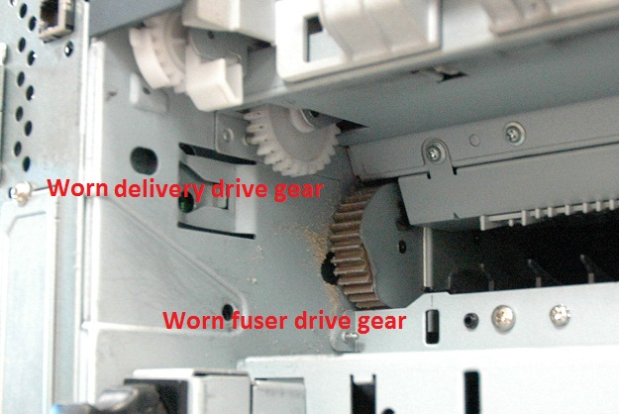

Lower pitched gear noise
If the fuser drive unit is showing wear, it can produce noise when a new fuser is installed into the printer. The worn in gears on the fuser drive unit will be noisy when meshing with a brand new fuser gear on a new fuser. The fuser drive unit should be replaced when new fusers are installed and they produce more noise than the old fuser. The replacement part number is RC2-2432. Figure 1 will show a worn fuser drive unit while installed. Note the brown dust around the brown gear. The majority of wear on this drive unit is on the white gear marked with an “X” on figure 2. This gear is not visible when the drive unit is installed on the printer.

